
Odd Man Out: Minimum Requirements

The following are the base level elements needed to produce Odd Man Out at the expected level:

Personnel:
- Each episode of Odd Man Out requires between 6-8 unique cast members (it could be more if the topic is something to do with couple but 6-7 is the common number of individuals as often more can get too difficult to handle).
- On set crew is ultimately up to your production, but at a minimum this show requires a sound recorder and three camera setups. As well as a separate director who is guiding the participants, explaining the rules, nudging certain conversations, and running the set. The director should have enough support to be able to focus on the contestants.
- Ensuring diversity and variety in thoughts, opinions, and backgrounds in casting is essential, as people should by in large not fit the expected stereotypes for the given topic.
Equipment/Logistics:
- As noted above, three cameras are the minimum requirement to get all the necessary angles. Usually, a master shot and two coverage medium shots, as well as some establishing wider shots for effect.
- Additionally, each episode requires an individual interview setup before & after the game. These interviews should be shot in both a medium AND a closeup.
- The set requirements are simply a black studio space and an LED setup as similar to this as possible – while it does not need to be EXACT, it should be as close as possible - and It DOES need to resemble the participants being inside of a BOX:

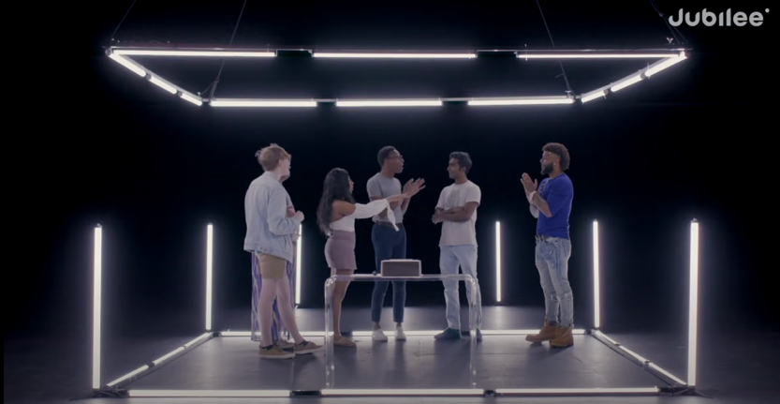
- The LEDs must be able to change color to RED and GREEN for the final reveal.
- A normal Shoot Day encompasses 4-5 episodes, so a Season is normally shot in 2-3 days.
- There should also be a similar clear table with paper and pens, a “Voting Box” and later “Cash Prize” Box accessible to the contestants.

